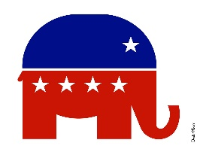

[This Photo](https://www.flickr.com/photos/donkeyhotey/6262125642) by Unknown Author is licensed under [CC BY](https://creativecommons.org/licenses/by/3.0/)

Point Pleasant Beach Regular Republican Organization

&

Committee to Elect Ramos, Cortes & Betten

Cordially Invite you to a Cocktail Reception Fundraiser

Honoring

Michael Ramos

George “Andy” Cortes

David Betten

**Republican Candidates for Council**

**Wednesday, September 4, 2024 from 6:30 – 8:00 PM**

The Offshore Restaurant

225 N Ocean Ave, Point Pleasant Beach, NJ 08742

$500 Minimum - $2,500 Maximum Supporter Sponsorship

For More Information or to RSVP:

[Mikeramos732@gmail.com](mailto:Mikeramos732@gmail.com)

Paid for by The Committee to Elect Ramos, Cortes & Betten